RDASH Adult Autism Diagnostic Service

Referral Form for Adult Autism Diagnostic Assessment

Please note that this referral form can be completed and submitted by the patient themselves or by someone supporting the patient. As such, the questions asked within this form are directed to the patient in order to capture their difficulties as much as possible. Patients will also need to fill in the AQ10 which is at the end of this form.
Disclaimer Statement-
By submitting this referral for form, you, as the patient are consenting for the autism team to access your NHS electronic health care record as part of the information gathering process. A copy of this referral form will be uploaded on to your NHS electronic health care record.

Date of Referral
Patient Name
Patient’s Preferred Name
Preferred Pronouns
NHS Number (If known)

Date of Birth:

Contact Details (Address and Telephone)
Patient email address:
Best way to contact patient:

If not patient:
Referrer Name & Contact Details
Relationship to the patient
If the referral is being submitted on behalf of a patient, does the patient consent to the referral being made? | Yes ☐ No ☐
Registered GP details (if not referrer)

Summary of Difficulties
Please use the tick boxes below to indicate any of the following difficulties that you may experience. Please give examples and tell us how these difficulties impact on your daily life.
If you do not provide sufficient information this could lead us to decline your referral based on there not being enough evidence to warrant a diagnostic assessment.
Difficulties  (tick which apply) | Impact on Daily Life  Please give examples in each section and describe how the difficulties you have ticked impact on your life at present?
Social Communication

☐difficulties with verbal and non-verbal communication (avoiding eye contact/difficulties understanding facial expressions, social cues)

☐difficulties starting/maintaining two way conversations, knowing what to say to others.

☐ Difficulties understanding language, needing people to be clear in what they say to avoid misinterpretation. Difficulties understanding jokes/sarcasm/literal interpretation of language .

Social interaction

☐difficulties understanding other’s emotions/other’s point of view

☐difficulties fitting in socially

☐difficulties initiating and maintaining friendships and relationships

☐Needing time alone

Difficulties  (tick which apply) | Impact on Daily Life  Please give examples in each section and describe how the difficulties you have ticked impact on your life at present?
Routines/Ritualistic behaviour

☐have fixed daily routines

☐Struggle with change, cope better with preparation

Intense interests and Focus
☐intense interests/intense focus on certain things/areas of life

Sensory Experiences
☐hyper-/hyposensitive to one or more senses (i.e. noise, light, smell, touch, taste)

Have your difficulties above been longstanding (i.e. since childhood or adolescence)? | Yes ☐ No ☐ Don’t know ☐

Have you had a diagnostic assessment for autism before?  (This may include assessments for Childhood Autism, High Functioning Autism, Asperger’s Syndrome) | Yes ☐ No ☐  If yes, when did this assessment take place?  What was the outcome of this assessment?
Why would an autism assessment be helpful for you?  (Tick which apply)  ☐ Current difficulties in seeking/maintaining your employment  ☐ Current difficulties in an education setting  ☐ Current difficulties maintaining your independence  ☐ Understanding your mental health  ☐ Other (Please specify…..) |  | Please provide more information about your reason for seeking a specialist autism assessment below:
Have you been referred/or are you currently on a waiting list to have an autism assessment in another service? |  | Yes ☐ No ☐

Mental Health and Risk
Are you experiencing any current mental health difficulties? | Yes ☐ No ☐  If yes, please share more information about these difficulties below:
Do you have any other mental health diagnosis? | Yes ☐ No ☐  If yes, please outline the diagnosis that you were given and when you received this below:
Are you currently accessing any other services in relation to your mental health? | Yes ☐ No ☐  If yes, please give more details:
Are you currently experiencing a mental health crisis including any plans/thoughts to end your life? | Yes ☐ No ☐  If you are experiencing a mental health crisis, feeling suicidal or in need of urgent support to keep you safe, then please phone crisis support for free on the numbers below:  - Crisis line: 0800 804 8999  - Phone: 111 and select the mental health option  Please note we cannot offer any crisis or mental health support whilst patients are waiting or receiving care from our service.

Additional Information:
Is there anything more about your difficulties or experiences that you would like us to know more about? | Please outline this below:

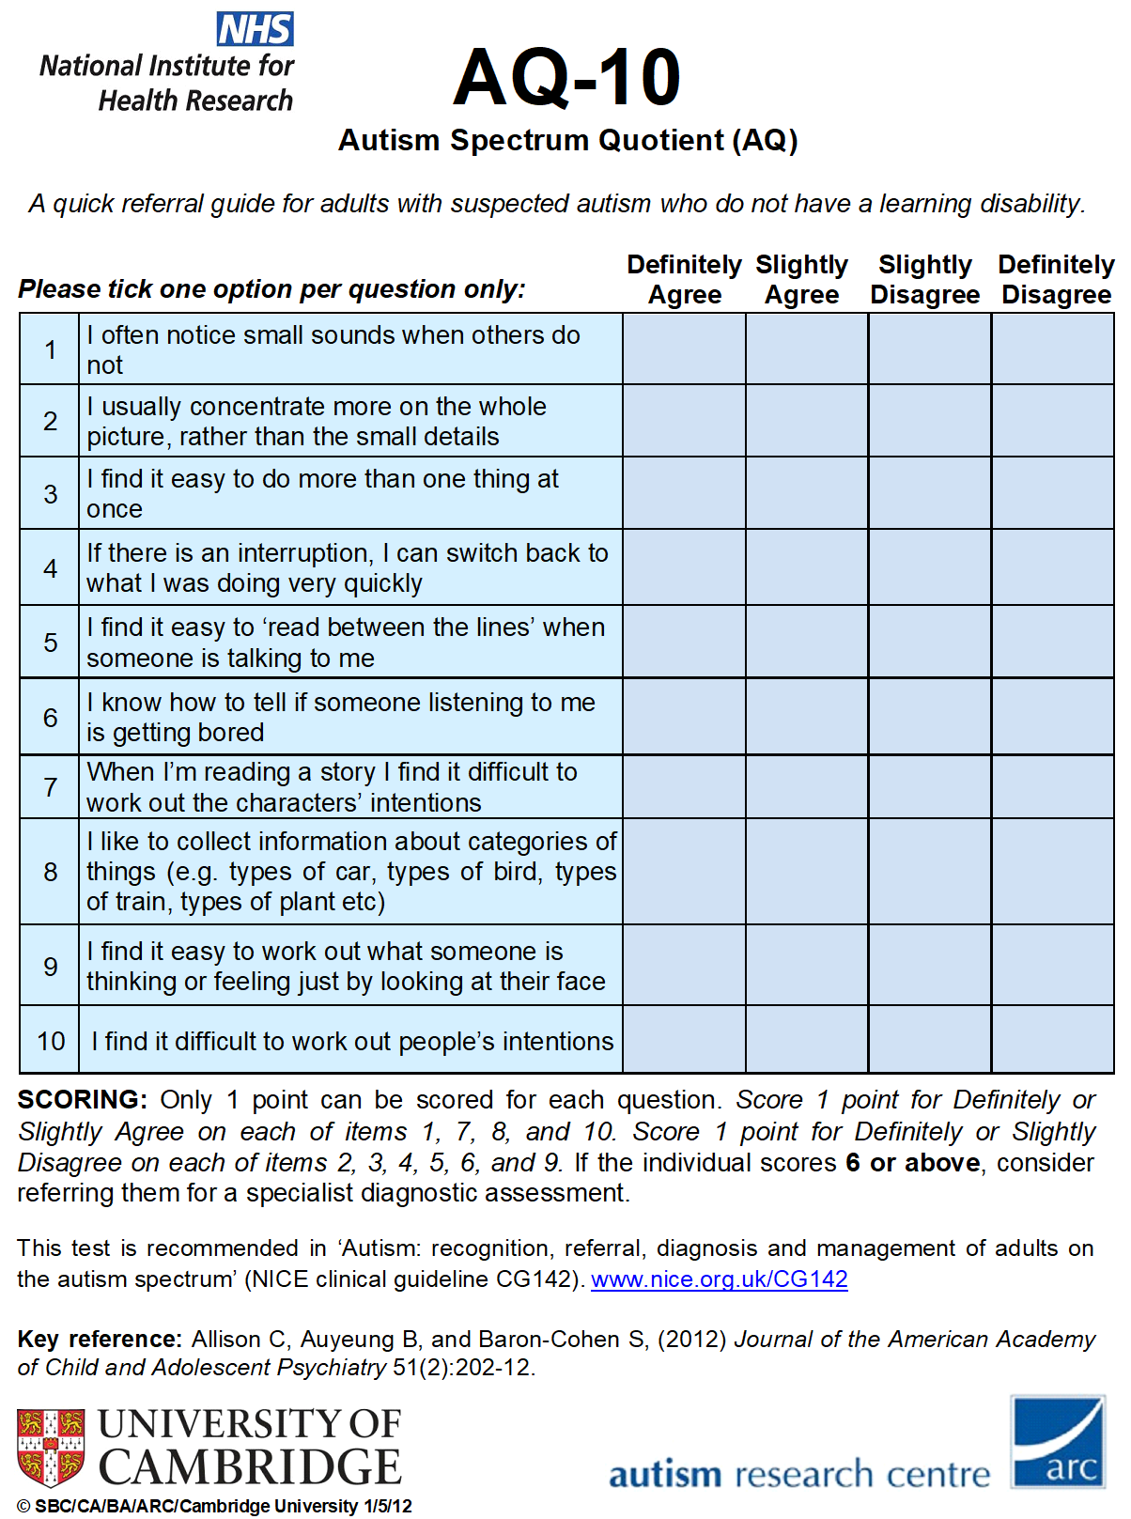

Thank you for completing this referral form, once we have reviewed your form, we will get back to you to let you know whether your referral has been accepted or not.
Please sent to:
Email: rdash.adhdandautismreferrals@nhs.net
Central Address: RDASH Adult Neurodiversity Service, The Neurodiversity Centre, Askern Road, Doncaster, DN5 0JR

